Figures

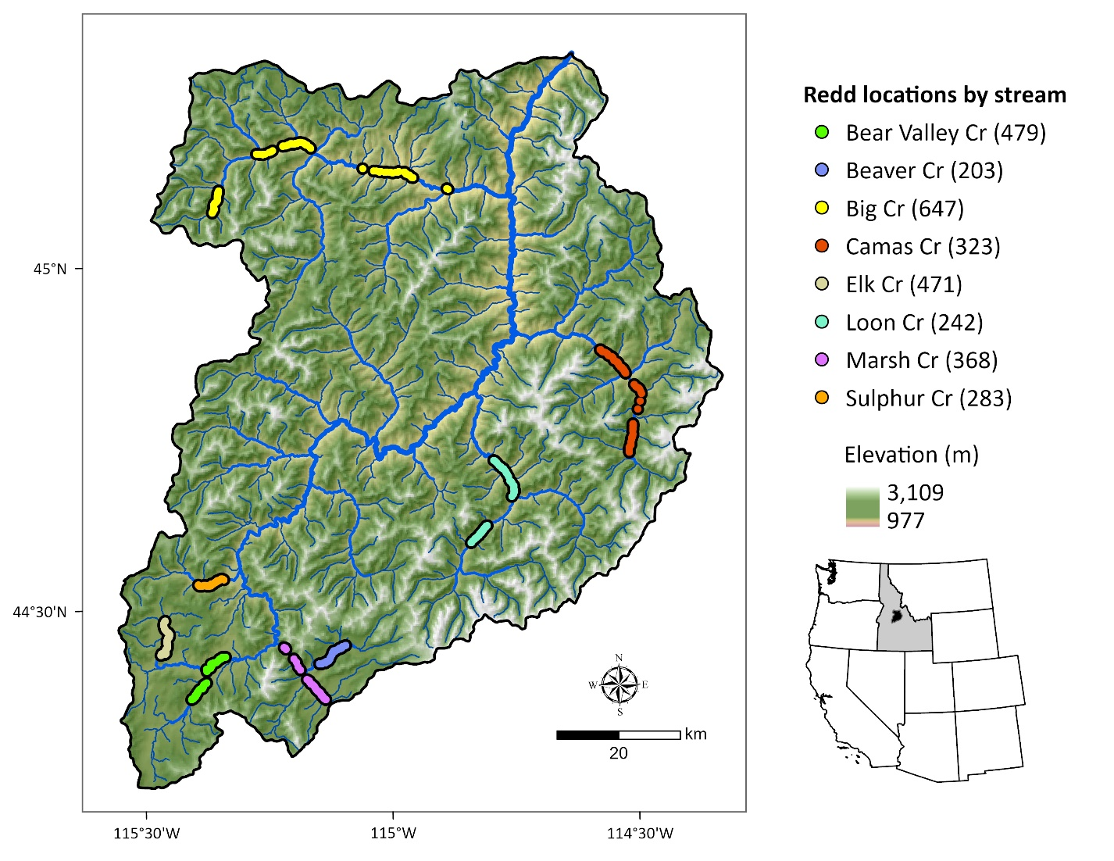Figure 1. Middle Fork Salmon River watershed illustrating major tributaries and surveyed segments containing georeferenced Chinook salmon redds from 2002 to 2005 (count of redds per stream in parentheses). Point locations were dissolved for visualization.

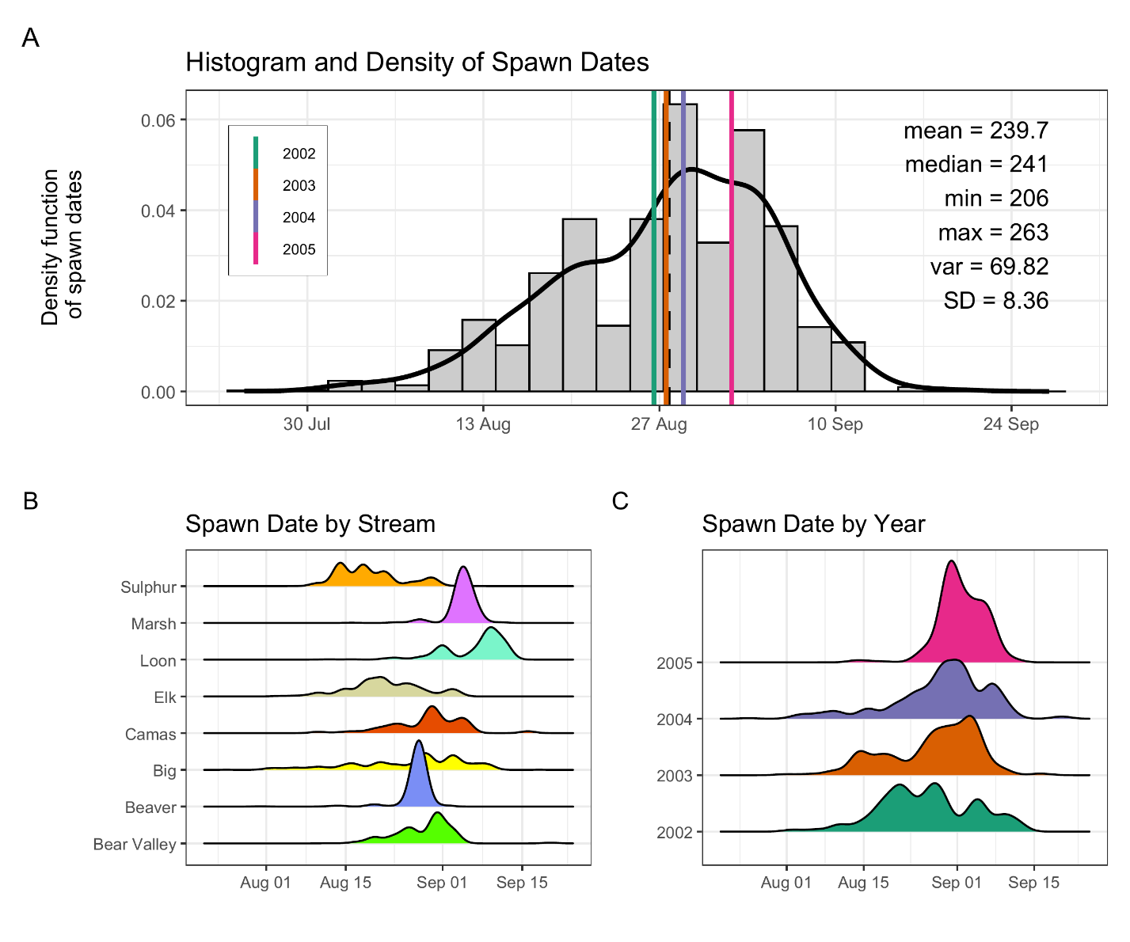
Figure 2: Histogram and density of Chinook salmon spawn timing across all streams and years (A), by stream (B), and by year (C). In panel (A), the histogram and kernel density illustrate the overall distribution of spawn dates; vertical-colored lines illustrate year-specific means, and the black dashed line depicts the global mean. Spawn timing was generally unimodal, peaking in late August to early September.

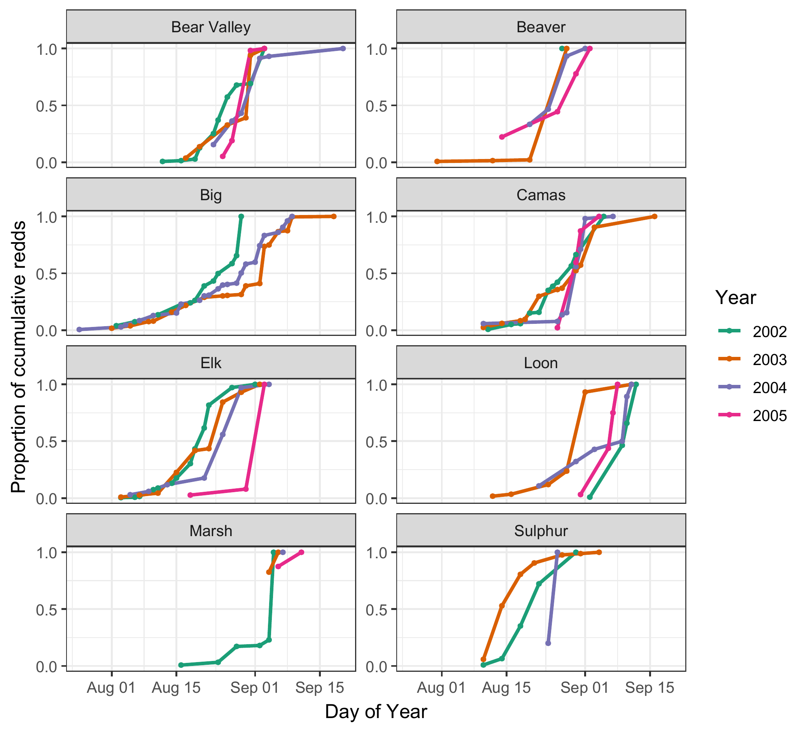
Figure 3. Cumulative proportion of Chinook salmon redds over time (day of year) across years (2002–2005) and streams. Each line represents a different year, denoted by color. Stream-specific panels illustrate temporal variation in the progression of spawning activity, as measured by cumulative redd counts normalized to the maximum value in each stream-year combination. From 2003-2005, only 2, 1, and 2 redd surveys, respectively, were completed in Marsh Creek.

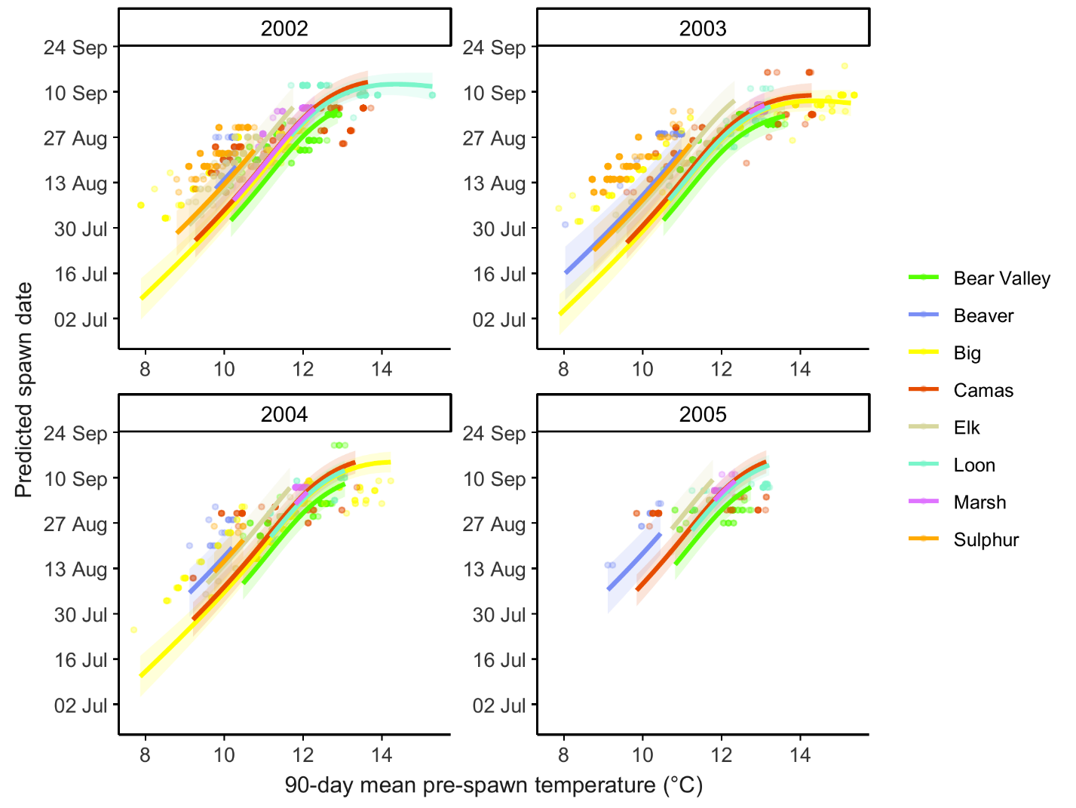
Figure 4. Predicted relationship between spawn timing and 90-day pre-spawn mean temperature by stream and year. Lines represent population-level model predictions from the final mixed-effects model. Colored points illustrate observed spawn timing; shaded ribbons represent 95% confidence intervals.

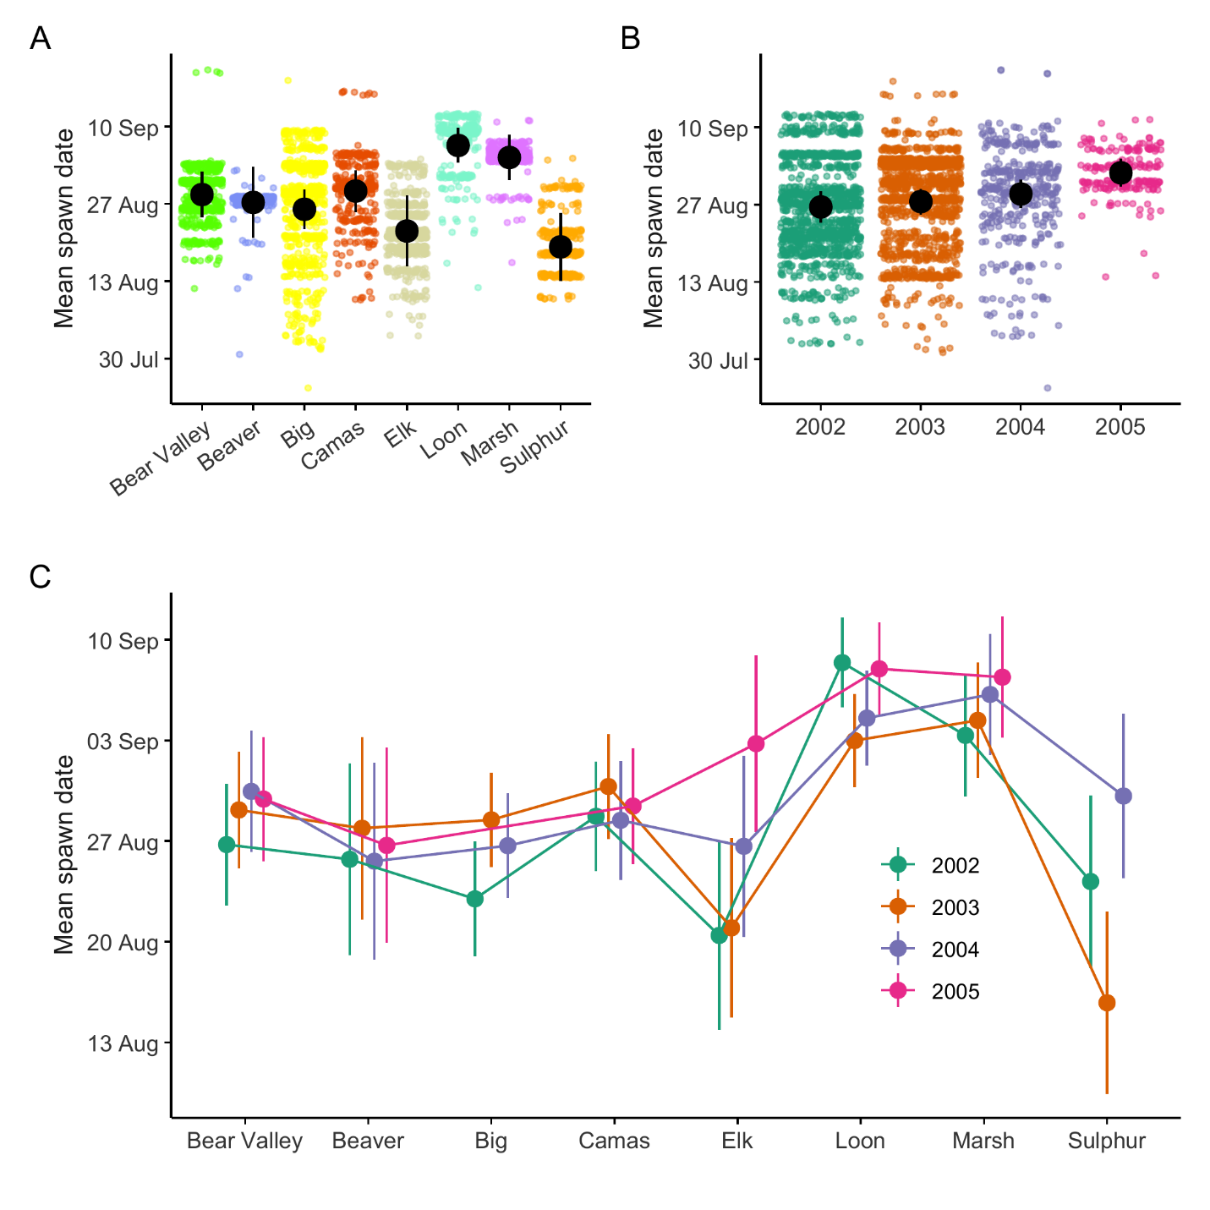
Figure 5. Predicted mean spawn dates by stream (A), year (B), and stream × year (C) from the final mixed-effects model. Black points and lines in panels A and B represent estimated marginal means and 95% confidence intervals averaged over random effects. Colored points illustrate individual redd observations. Colored points and lines in panel C represent stream-specific marginal means and 95% confidence intervals by year.

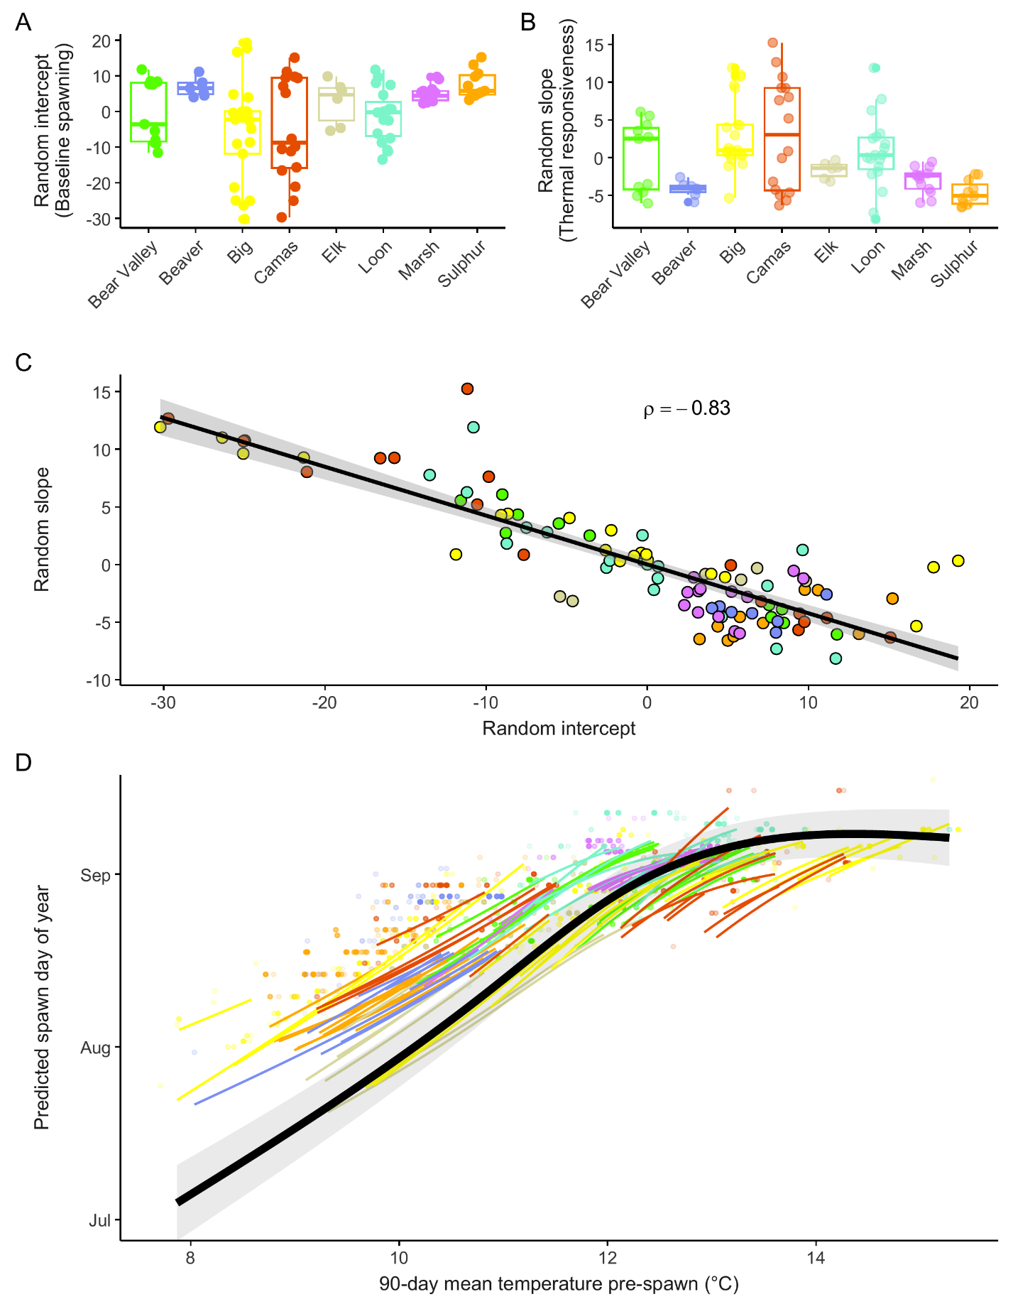
Figure 6: Reach-level (COMID) random effects and predicted spawn timing relationships from the final mixed-effects model. (A) Random intercepts by stream, representing reach-level deviations in baseline spawn timing after accounting for fixed effects; positive values indicate later-than-expected spawning. (B) Random slopes by stream, representing reach-level deviations in thermal sensitivity; larger positive values indicate stronger temperature dependence. Points in A and B represent individual COMIDs. (C) Correlation between random intercepts and slopes across all COMIDs, colored by stream; the strong negative relationship (ρ = −0.83) indicates that reaches with earlier baseline spawn timing exhibit greater thermal sensitivity. (D) Predicted temperature–spawn timing relationships for individual COMIDs (colored lines) and the population mean response (black line with 95% confidence interval).

